

Imogen Whitaker - Clerk & RFO to the Council
T: 01243 575094/clerk@boxgroveparishcouncil.gov.uk
www.boxgroveparishcouncil.gov.uk

__________________________________________________________________________________

Minutes of the Hybrid Parish Council Meeting

Monday 13th April 2026 at 7.00pm

Present:
Cllr H Potter - Chair, Cllr Tynan, Cllr Bish, Cllr Barnes, Cllr Howton, Cllr Lovejoy, Cllr Raikes

In attendance: The Clerk (zoom) CDC – Cllr Henry Potter
WSCC: Cllr Jeremy Hunt 10 members of the public

- Apologies
Cllr Matters – work commitments; Cllr Moore – holiday.
- Declarations of interest
There were none.
- Minutes – to agree and sign the minutes of 2nd March 2026.
The Minutes were unanimously agreed to be a true and accurate record and were
duly signed by the Chair.
- County Councillor, District Councillor and Chair’s report
Cllr Jeremy Hunt WSCC – deferred to after item 12

- Cllr Henry Potter CDC
- Cllr Potter continued to be amazed by the diligence of the Community Speed Watch Team in the work they continued to do, and the latest efforts to pursue new Average Speed Cameras on the A 285 in Halnaker. The recent approach to Katy Bourne, the Police and Crime Commissioner was to be commended and Cllr Potter once more offered massive thanks for the excellent work.
- Cllr Potter felt that the 20 mph limit in Boxgrove was being better observed whenever he drove up the Street.
- The Spring Coffee morning held on March 26th at the Village Hall was very well supported but Cllr Potter had been disappointed that so few people from Boxgrove and Halnaker attended. There had been so much to occupy folk especially children, teas and coffee, bacon sandwiches and cake!! There was a sort of cake to suit everyone’s tastes! Cllr Potter gave a word of warning, that Singleton and Charlton had carried out a survey among residents asking for thoughts regarding their Village Hall. Similarly, East Dean were likewise concerned about the future of their little Hall. Both had suffered lack of support for functions that had been promoted and were anticipating financial support from their Parish Councils. “If you don’t use it, you’ll lose it”. Boxgrove Village Hall was keeping its head above water mostly due to hosting weddings and a few funeral ‘wakes’ but it was not getting any easier. So he asked residents whenever possible to please support these events.
- Cllr Potter was pleased to hear that the most active Rangers, Cllr. Mike Howton and Graham Dipple had successfully planted the trees that were provided by CDC as part of their “Plant a Tree” initiative and a second batch of eight ‘in pots’ saplings had been received. Again, thanks to them both.
- The roll out of the separate Food Waste collections had fallen behind schedule. It had supposed to have been finalised and up and running by end of March but as yet the necessary containers had not been received. This area is not alone – Cllr Potter’s daughter in Arun had only received them at the beginning of April but they were not yet being collected.
- The draft Housing Delivery Statement referred to in minute 9 of the March minutes was no clearer. Recent discussions had proved there was nothing the Local Planning Authority could do to boost the supply of housing. It was still the case that if developers could not sell them, then they were not going to build them. The February planning committee agenda had NO applications and the March agenda only three, two of which were for Gypsy and Traveller settlements. The April agenda included just one for Pinewood House within Graylingwell to convert from student accommodation to 51 short stay units specifically for homeless folk. None of these would contribute to the requisite 5 year housing land supply of 735 units per annum.
- Finally, Cllr Potter met with a Portsmouth Water engineer who clarified without ANY DOUBT which water meter served the Sports Pavilion and which, the Village Hall. If the commercial supplier Castle Water could not understand now, he was unsure what they would try.

End of report.

- Cllr Henry Potter CDC report
- On April 1st, the Chief Executive of the Council Diane Shepherd addressed all Members via Teams to outline the latest developments of the Local Government Reorganisation relating to the proposed new Unitary Authorities for Sussex. Despite the tremendous amount of work at meetings of the Senior Officers and Leaders of the Local Authorities involved since before Christmas, Mr. Steve Reed, the Minister for Communities, Housing and Local Government had seen fit to propose alternatives which bore no resemblance to the proposals of CDC, Arun, Worthing and Adur as the best option for our Districts. This raised objections from those concerned and any decision was deferred to at least until after the County Elections on 07/05. Mr Reed claimed that this would give more time for further examination and consultations to help the decision making. The chances were that this would be delayed until June or even July. The later the announcement was made the greater the pressure on the timetable for Local Government Reorganisation and the absolute necessary reorganisation within the new Authorities. Ms Shepherd briefly outlined what would have to be done within the component Councils to harmonise everything to be equal and fair for all residents. It was, to put it bluntly, a minefield! There was so much to be done. There would be NO District Elections next year so Members would continue for one additional year, but if somehow the timetable was able to get back on track, there would be an election of a “Shadow Authority” to manage the transition until 2028 when they hoped it would be completed. Cllr Potter had gravest doubts.
- Other news of the Council: it had been agreed that £600,000 would be taken from Reserves and contributed to WSCC to enable the transformation of the City Centre, especially North and East Streets. This would include a complete replacement of the roads and pavements, new seating, greenery and planting to create an attractive, more welcoming environment. New signage would be introduced to help visitors find their way around and learn more about the heritage of the city. Additional funds were to be released to carry out necessary repairs to two boundary walls in Selsey.
- The Public Space Protection Order, Dog Control 2026 was being consulted on with a view to extending areas where dogs needed to be controlled. This would soon be applied to areas outside the responsibility of CDC, for example, Parish Councils might wish to have the PSPO applied to areas under their control such as playing fields and children’s play areas. Almost certainly there would be additional controls around the foreshores where ground nesting birds are found.
- Finally, an additional meeting was being arranged for all Councillors outlining their responsibilities regarding Standards and Code of Conduct. It was recommended and the date would be 20th April 2026.
End of Chairman’s Report.

- State of road surface at end of The Street : to discuss and action to be taken – deferred to arrival of Cllr Hunt
- Public Question Time from residents (Standing orders 3d – 3l)
A member of the public questioned the increase of the Parish Council contribution to the council tax as being higher than that of WSCC at 20%.
WSCC council tax is capped at an increase of 5%. The 26 – 27 budget for the Parish Council saw an increase of 5.44% (£2.44 per week for a tax band D property). The clerk will send the details to the resident and any other resident who requests them although they were printed in the Minutes of 1st December 2025.
The member of the public who had brought the attention of the council to the increase in car parking charges (reducing free parking) at Southgate reported that they had not gone back to the original system exactly, but had increased the amount of free parking to 3 hours for the leisure centre with a further 2 hours possible, which was a vast improvement.
- Crockerhill – update
Nothing new to report – the same mayhem with vehicles everywhere being worked on and no clearing up afterwards. One vehicle parked up in front of the Winterton making it impossible to access. The horse box which had been moved out of the field onto the road for repair was still there. Cllr Potter reported that when he had visited all the stone kerbing had been destroyed by heavy vehicles.
Clerk to write to Traffic Commissioner.
Action Clerk
- Interviews for new Parish Clerk – team and procedure to be followed.
One of the candidates who had attended the meeting was asked to leave the meeting for the duration of this item.
The staffing committee (Cllrs Lovejoy and Barnes) and Cllr Potter will be on the interviewing panel on Wednesday 15th April from 3 – 6pm. Cllr Potter said there had been four candidates but one had found a post already. The clerk had circulated examples of questions etc to the team. No other requests were made of the panel.
- Boxgrove Neighbourhood Plan update
Mr Leah said that there was not much to report and the team has finished what they set out to do. CDC has not advertised the Consultation yet, but they will try and advertise for 25th April.
The team is hopeful that the Inspector will have finished by the end of the Summer. The big disappointment is that the Folly application has still not been to committee which is very frustrating. Unless this moves forward the application will be withdrawn.
Mr Leah asked the Clerk to chase for the notes from the Planning meeting which had been held by CDC.
Action Clerk
CDC are unable to increase their land supply to meet the requirements and a call for sites has gone out.
- Planning Applications to be decided.
Planning number | Address | Detail | Comments
BX/26/00553/DOM  BX/26/00554/DOM | Rose Cottage Halnaker Boxgrove Chichester | proposed rear conservatory | No comment but too little information for listed building
BX/26/00260/FUL | Recreation ground | Boulodrome | Support
BX/26/00297/FUL | Anglesey arms | Single storey front/side extension and associated works. Removal of one tree adjacent to the property | OBJECT: the design and build quality are not in keeping with a listed building, and will look dilapidated extremely quickly. The number of patrons is being increased but the sanitary facilities are poor and there are no accessible toilets for the disabled.
BX/26/00686/FUL | Land south of Eartham quarry | to change use of land to an enclosed canine field | SUPPORT
Delegated planning decisions to be noted:
Planning number | Address | Detail | Closing Date
BX/26/00350/LBC | Nightingale Cottage The Street | Addition of Secondary Glazing | WITHDRAWN
- Clerk’s report
- Correspondence received
- Two members of the Community Speed Watch who have been working hard on Average Speed Camera research and hopefully installation, had contacted the clerk to update the council with all the information in Appendix 1.

They asked the council to support them with follow-up letters to Katy Bourne and Andrew Griffiths MP. They asked for engagement at meetings with a nominated councillor (Cllr Tynan), and to be able use the Council’s endorsement of this project in correspondence. They also requested a small article in the council newsletter.
Action Clerk
Further information on this project can be obtained from the clerk.

The chair congratulated them on all the work they had done, and progress made for road safety in Halnaker.
- The clerk had been contacted by the contractor who cuts the paths across the common. He had said that the landowners and tenant farmers were consistently damaging the paths and that the Blunden’s Lane path was about 4ft smaller than previously.
The Clerk suggested that the Rangers could take on the management of the footpaths across these areas. When the paths were damaged, they could contact the landowners and tenants to make sure that they restored damaged paths etc. The WSCC PROW team does do some of the paths but only those that are under their remit. The whole area needs to be mapped out and noted who is responsible for what, so that the right people can be contacted. Mr Dixon said that there was a time when electric disabled buggies could easily go across these areas but that is no longer an option.
It was agreed that the responsibility of the land rented by Barfoot’s was the landowners the Greens. They need to make sure that their tenant respects the footpaths.
- Request to use Boxgrove Recreation Ground for 23rd May 2026
Not covered
- Request for S137 funds for Village Hall, Village Fayre
A sum had been put aside in S137 funds to contribute to the hall’s running of the Village Fayre. Cllr Potter proposed and Cllr Barnes seconded the donation of £500 to help with the running of the event. This was unanimously RESOLVED.
- Payments for Consideration
Cllr Potter questioned the payment to DCH. This was for the boulodrome. The clerk explained that even though no buildings were being constructed a full planning application had had to be submitted for the boulodrome, with many and various drawings. A Bio diversity net gain report had also had to be included and the bill for that would be at next month’s meeting. The recent planting of the trees would hopefully count as the 10% net gain but the trees would have to be planted on the recreation ground.
Cllr Lovejoy proposed and Cllr Barnes seconded the payments for consideration. These were unanimously RESOLVED.
- Bank reconciliation – circulated
- Boxgrove Rangers
The Chair thanked Mr Graham Dipple, Cllr Howton, Sarah and William Heneker for the tree planting.
No other report.

WSCC Jeremy Hunt
Cllr Hunt said that as all members were in purdah prior to the WSCC elections he did not have much to report, but he had received information about the running of the Quarry site restoration. They do have site meetings and the last one was on 26th March with the arboriculturist. The vast majority has been completed and in accordance with the plans. The bat and bird boxes are still to be installed. There is a remaining small area of woodland also to be planted towards the end of November 26. It is not yet compliant but there are only minor issues outstanding.

Halnaker Windmill.
Unfortunately there has been a delay to the tender process for the windmill as a millwright had to be found and visit the site to verify that the tenders were compliant. The tenders are considerably more than expected and will have to be financially approved. It was mooted that the works should not go ahead and replace the sails (stationary) as before but this had been vetoed by the millwright.
Cllr Hunt apologised for the further delay but assured the meeting that it would go through, but unfortunately it would not be this summer.

Road surface at top of the Street.
A member of the public reported to Cllr Hunt that this was appalling with huge holes and bumps for 200m. This is a route for ambulances and should be better surfaced. Cllr Hunt said that the fastest way to get this looked at now would be by reporting it online.

Mr Leah asked what was happening at the Temple Bar roundabout. He understood that that there would be night closures in each direction on that section of the A27 for up to a year. Night closures would have a huge impact of rat-running through Boxgrove. Cllr Hunt said that any work on the A27 was the responsibility of National Highways and not WSCC highways. However, he would check with highways officers to see if they were aware of this planned work by National Highways.

- Date of next meeting
The next meetings would be on Monday May 11th 2026.
The Electors’ Meeting at 6.30pm and the Annual Parish Council meeting at 7pm.
These would be the first meetings for the new clerk.

There being no further business to conduct, the meeting closed at 8.30pm.

Signed: ______________________________ Dated: ______________________
Cllr Henry Potter - Chair

Appendix 1 – Average Speed Cameras
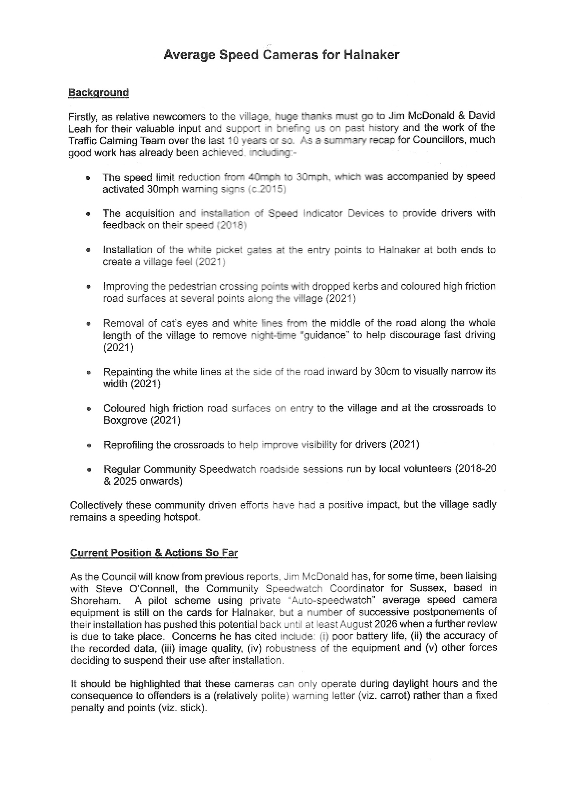
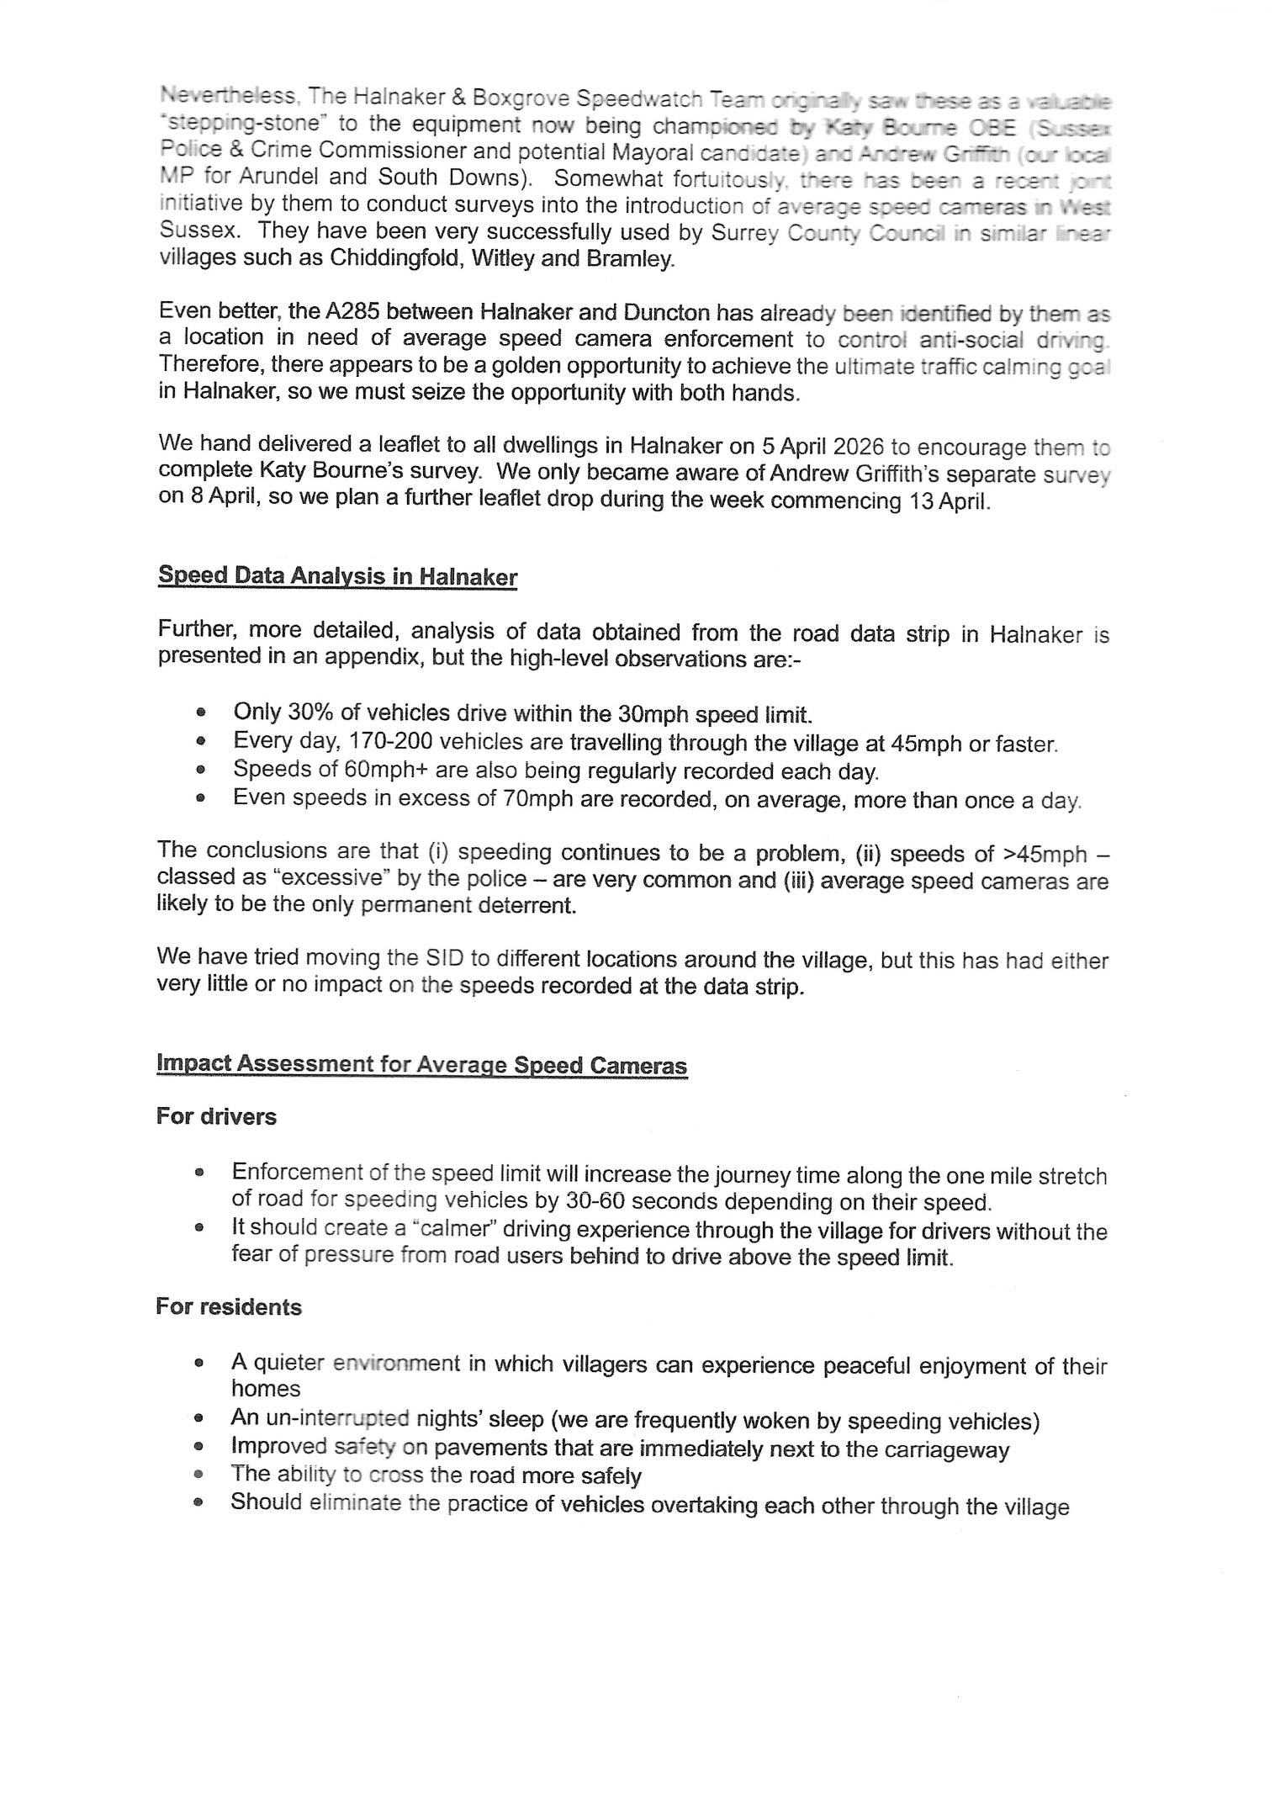

Boxgrove Parish Council Financial Statement
Meeting April 13th 2026
Balances on accounts |  | £108,974.37
 |  | £108,974.37
Received since last meeting
precept |  | £30,772.50
 | total | £30,772.50
Paid since last meeting
I Whitaker | Salary | £906.50
nest | pension | £66.11
Scribe | sub | £66.00
S&P tree specialists | felling of elms | £1,240.00
DCH | boulodrome | £385.00
 |  | £2,663.61
Payments for consideration
I Whitaker | clerk salary | £906.50
nest | pension | £66.11
HMRC | contributions | £237.27
arun district council | printing newsletter | £95.00
Graham Dipple | fertiliser trees | £24.48
RJ Dixon | grass cutting | £240.00
Zoom | zoom annual cost | £167.88
PWLB | loan repayment | £3,393.19
CDC | litter and dog bins | £2,551.51
Orchard IT | annual IT | £3,070.56
Orchard IT | Councillor laptop | £611.83
Orchard IT | Clerk's laptop | £331.80
DCH | boulodrome | £500.00
I Whitaker | Council costs 6 mths | £511.77
 |  | £12,707.90

Bank reconcilation April 13th 2026
Bank accounts as ofApril 10th 2026
current account |  |  |  |  | £108,974.37
 |  |  |  | total | £108,974.37
opening balance 1st April 2025 |  |  |  |  | £78,267.98
add receipts in the year |  |  |  |  | 30772.50
less payments in the year |  |  |  |  | £66.11
 |  |  |  | Balance | £108,974.37
less
reserve @ 50% of annual precept of £61545
 |  |  |  | Total | £30,772.50
less ring-fenced funds
neighbourhood plan |  |  |  |  | £1,000.00
cricket pavilion extension designated reserve |  |  |  |  | £13,059.83
capital replacement fund |  |  |  |  | £1,000.00
Boulodrome |  |  |  |  | £5,436.00
Trees |  |  |  |  | £3,760.00
Resilience |  |  |  |  | £4,000.00
Contingency |  |  |  |  | £1,500.00
Car park fund |  |  |  |  | £5,500.00
Fountain |  |  |  |  | £1,000.00
Traffic calming group |  |  |  |  | £3,916.00
Planning consultancy fund |  |  |  |  | £1,000.00
Rangers |  |  |  |  | £500.00
Bus stop |  |  |  |  | £1,700.00
 |  |  |  | Total | £43,371.83
total available funds |  |  |  | Total | £34,830.04
(less ring fenced and reserve)
Outstanding Loan for Village Hall |  |  |  |  | £49,510.99

