Listed buildings in Boxgrove

Priory Farmhouse
Square early C19 building. Two storeys. Three windows to each front. Faced with flints with white brick dressings, quoins and modillion eaves cornice. Hipped slate roof. Glazing bars intact. Doorway with rectangular fanlight and flat hood over.

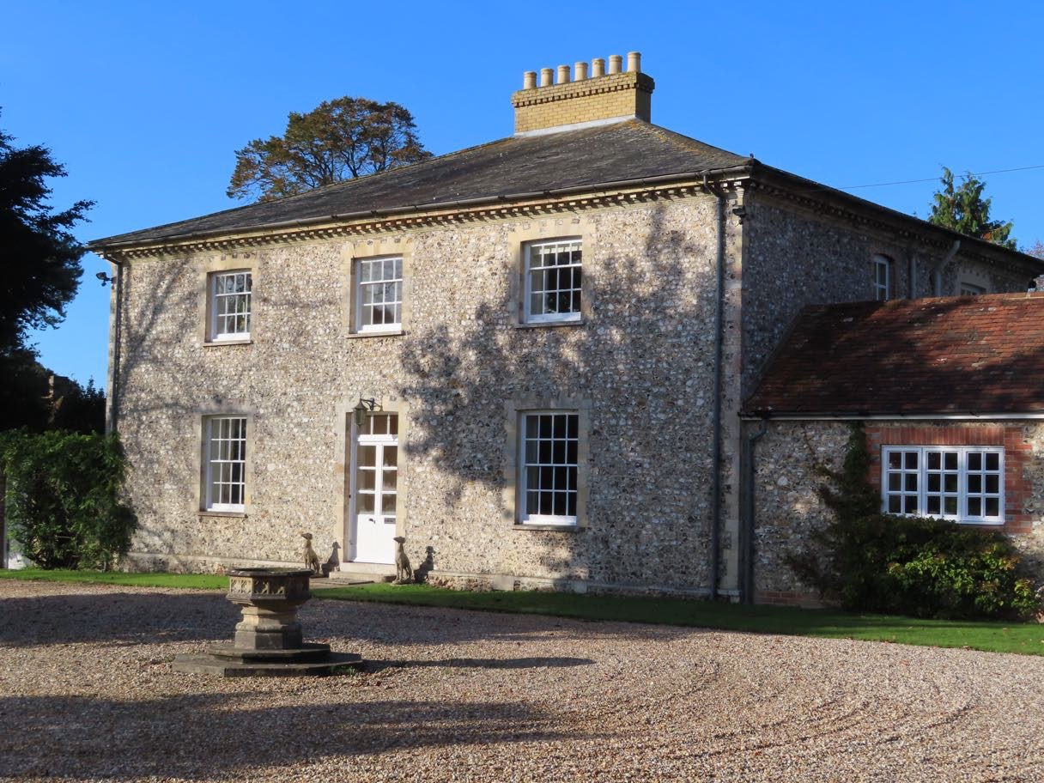

The Countess of Derby’s Almshouses
Founded in 1741 by the dowager Countess of Derby, daughter and heiress of Sir William Morley of Halnaker House. Three sides of a courtyard. Two storeys. Ten windows facing east, six windows facing north and five windows facing south. Red brick and grey headers. Tiled roof. Casement windows. The central or west side has a raised centre piece, faced with Roman cement and four large sash windows with glazing bars. In the centre is an inscription recording the founding of the Almshouses with a cartouche over it. Modern ground floor portion built out in front of this with gabled porch.

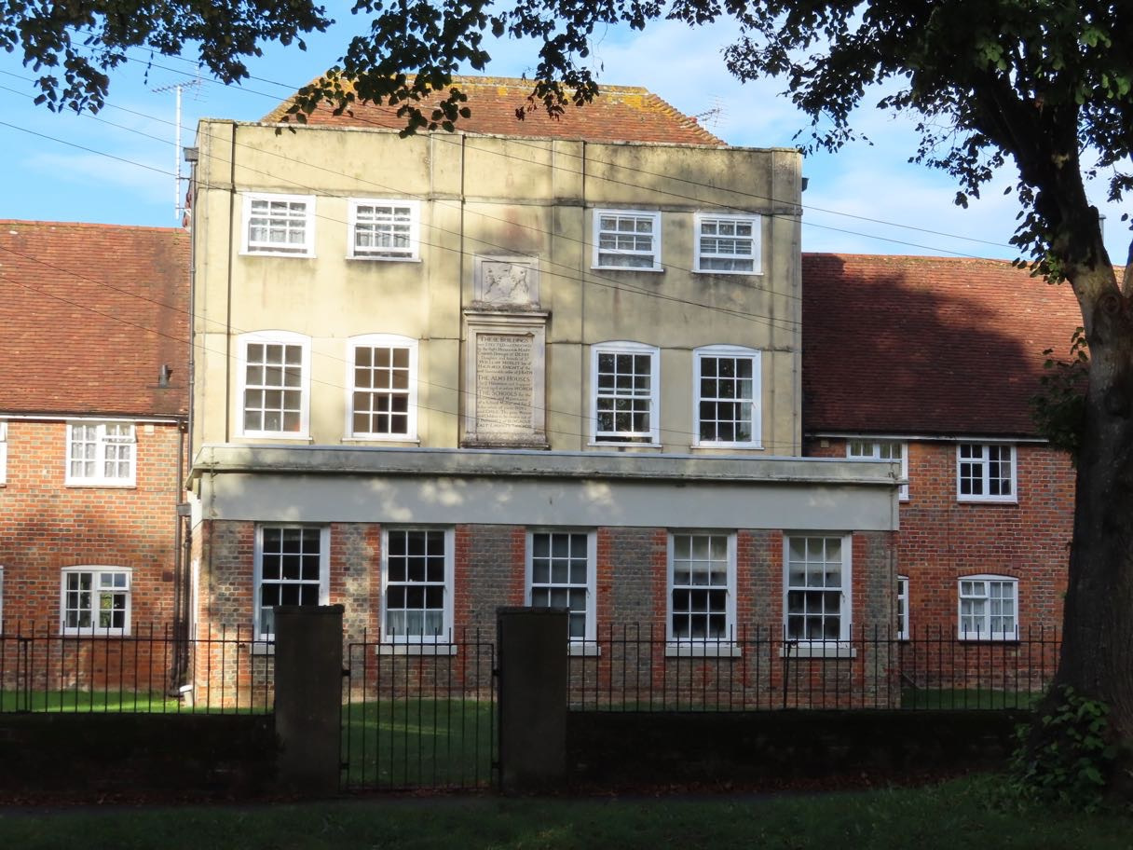

Nightingale Cottage [RHS, thatched, half-timbered]
Former Goodwood Estate number. C16 timber-framed buildings with red brick infilling, south end refaced with flints. Thatched roof. Casement windows with diamond-shaped panes. Two red brick buttresses on ground floor.

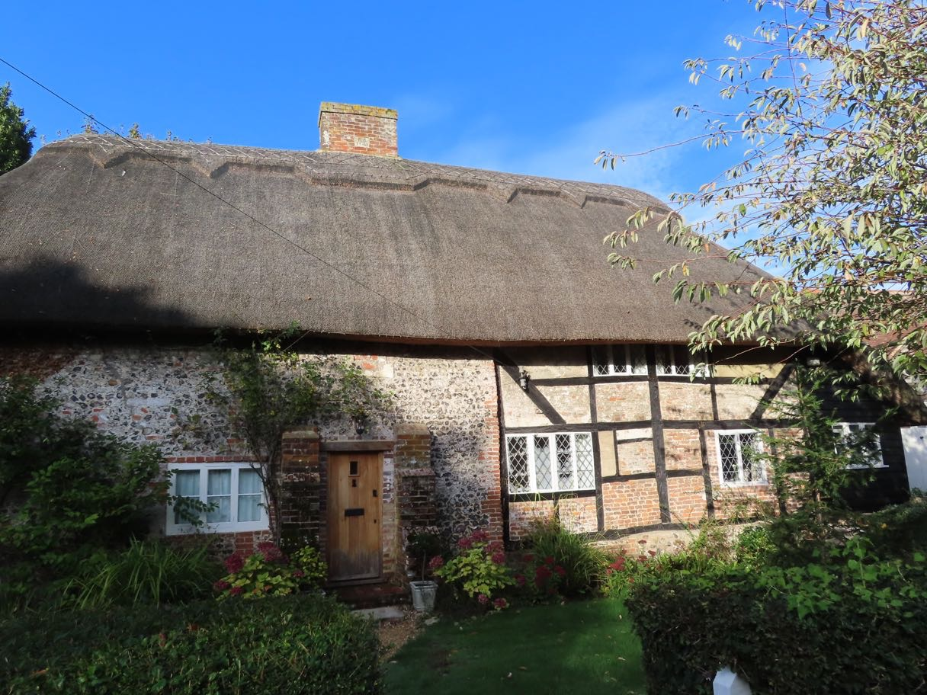

64 & 65 The Street [next to Nightingale]
Pair of cottages. Mid C19. Type known locally as Duchess Cottages. One building. Half-H plan. Two storeys. Four windows. Coursed flints with dressings, quoins, string course and dripstones over the windows, all of red brick and grey headers. Tiled roof. Casement windows. The end window bays project with gables over.

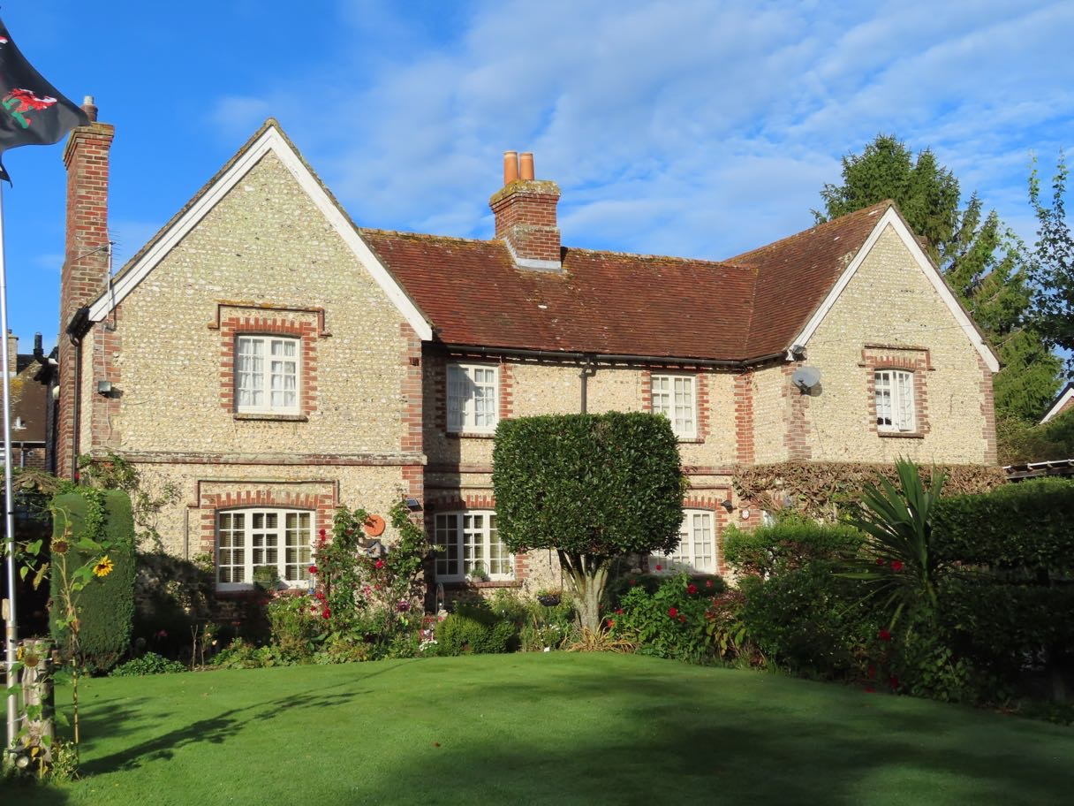

67, 68, 69 The Street
Cottage row. C16 with brick elevations, C18 to rear, C19 to front. Timber- framed red brick with gauged window heads on ground floor. Plain tiled roof with central and end ridge stacks. Two storeys. Irregular 4 window front, casements. Three boarded doors, one (No 67) to right of left-hand window, and two in centre (Nos 68 and 69). Interior: Evidence of timber-frame internally. Side purlin (structural member going lengthways in a roof) queen-post roof.

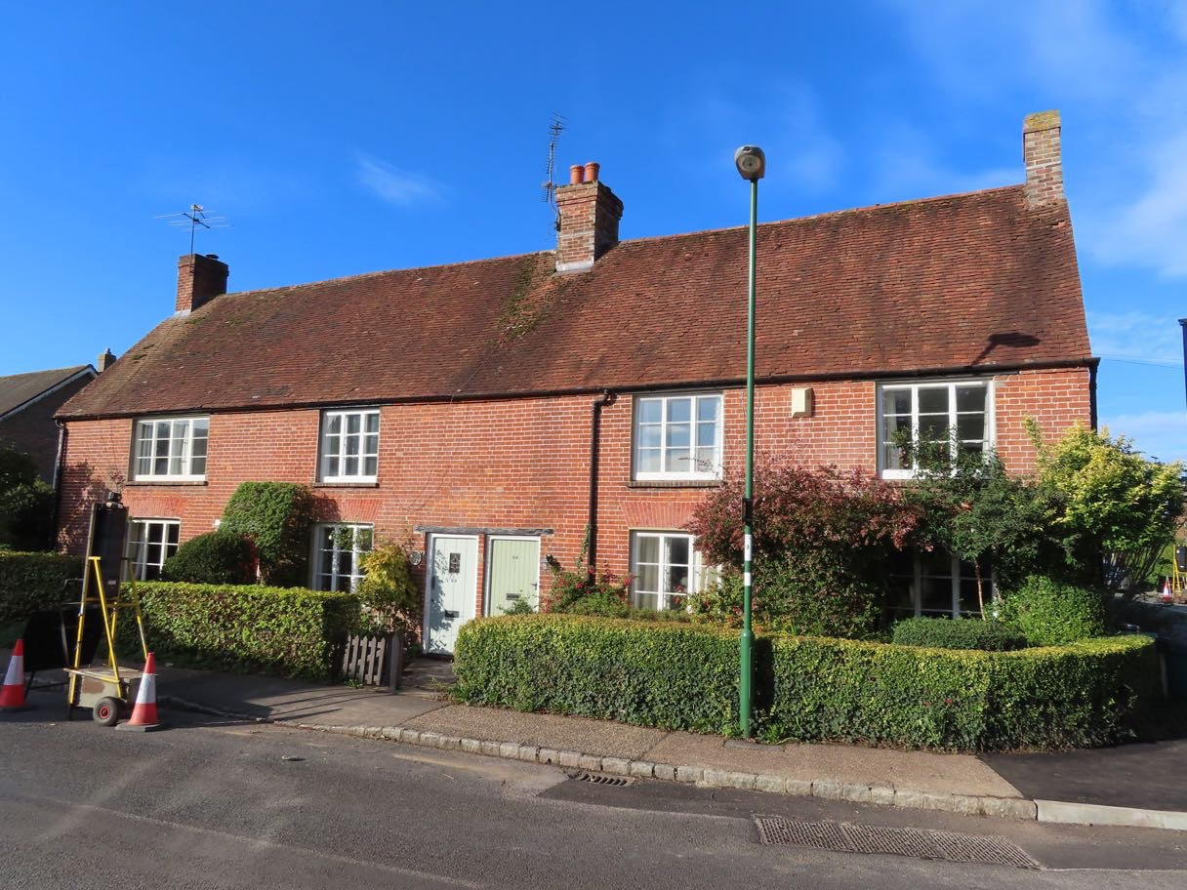

70 & 71 Church Lane
One building. Probably C17. One storey and attic. Plain tile roof hipped on north and descending low to rear over outshuts (asymmetrical end elevation of high eaves at the front and low eaves at the back) within no 71 and part of no 70. Flint walls with red brick dressings and quoins. Four window front, and one gabled and one flat-roofed modern dormer; modern casements. Inside, south and middle ground floor rooms with stopped and chamfered beam on north-south axis and joists; fireplaces, middle room fireplace with wood bressumer (structural timber, probably the lintel in this case, although often used in relation to a bay-window) and probably C17 timber framed north partition wall. North ground floor room with heavy chamfered (corner removed) beam on E-W axis with joists and with portion of clunch (hard chalk) walling with brick lacing courses to rear.

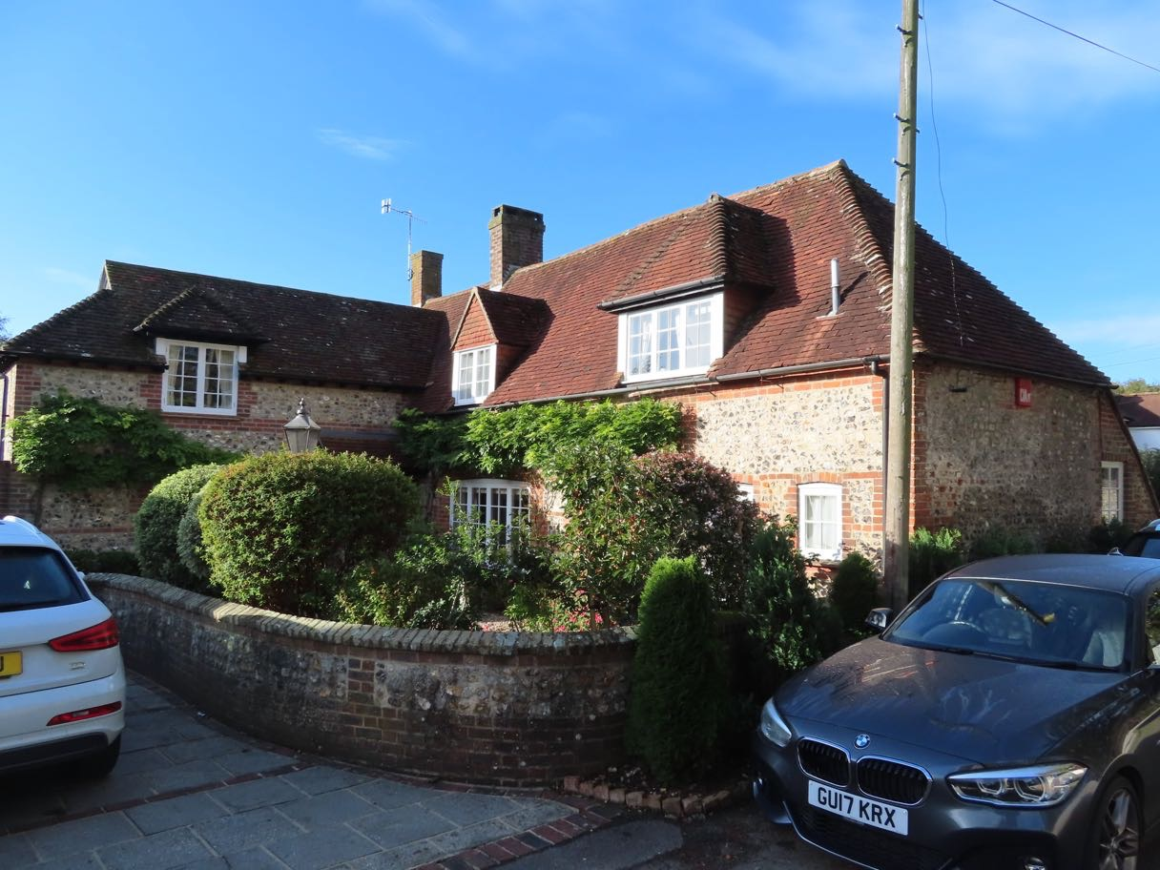

72 & 73 Church Lane
One building. Mid C19. T-shaped building. Two storeys. Four windows. Coursed flints with dressings, quoins and dripstones over the windows of red brick and grey headers. Tiled roof. Casement windows. Two gables to north wing. Gable ends east and west.

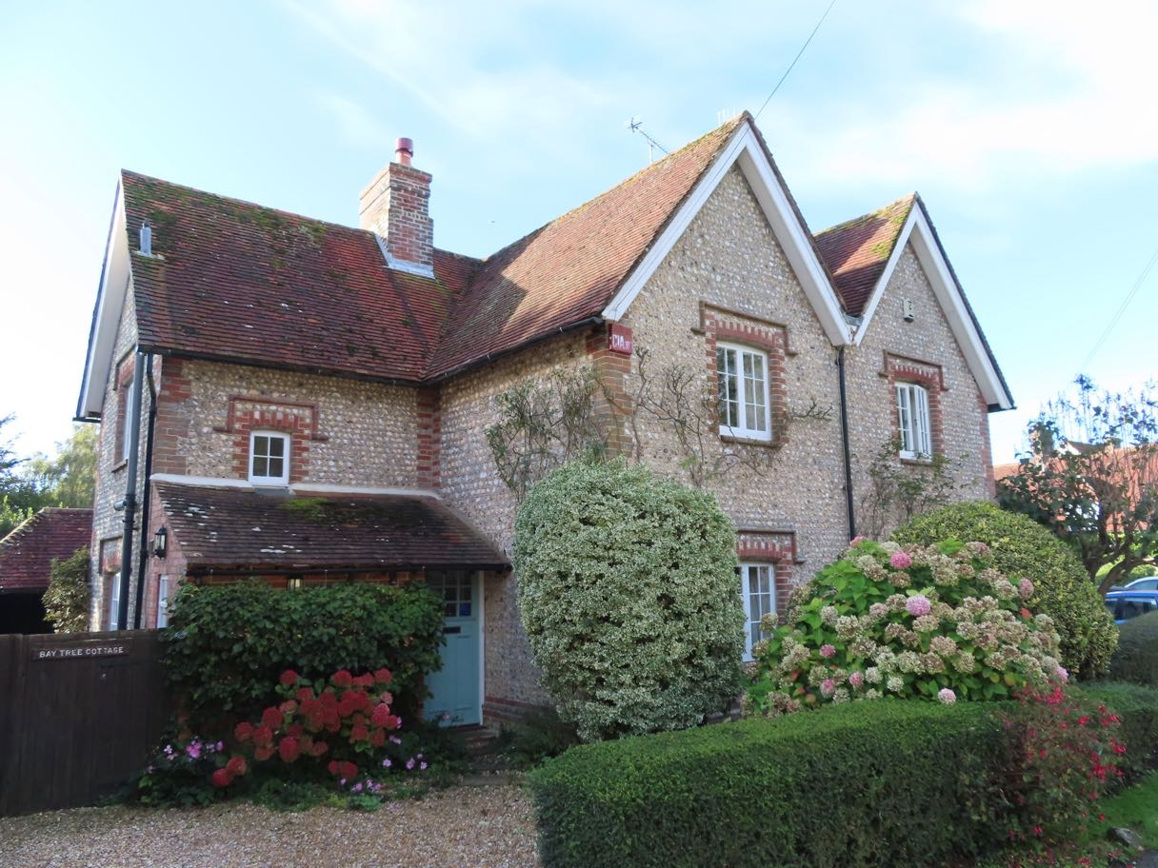

Thatch Cottage
Dated 1725. Two storeys. Two windows. Faced with flints with red brick dressings and quoins. Thatched roof. Casement windows. Modern porch. Stone with the date 1725 and the initials 'M.B.S.A.M.'

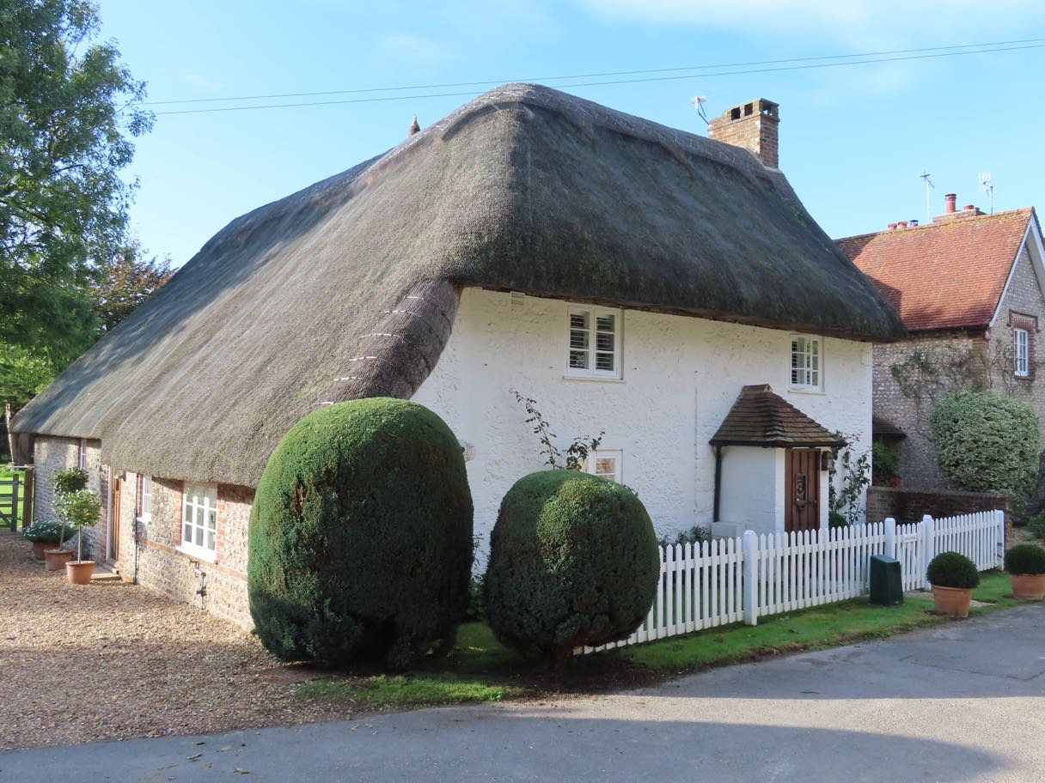

The Priory church of St Mary & St Blaize [Grade 1)

Founded about 1117. Built of flint with Lavant stone, Purbeck marble and Caen stone rubble dressings. Tiled roof. Of the cruciform church there survives the chancel with aisles, the central tower, the north and south transepts, the easternmost bay of the nave and the south porch. Most of this is from the original C12 building, but the chancel is C13. Flying buttresses. The porch is C14. The main part of the nave was demolished in the C18. At the north west corner of the north transept are the remains of three round-headed C12 arches of the former cloister of the Priory. Perpendicular font and De la Warn Chantry c.1526. [One of the finest medieval churches in Sussex.]

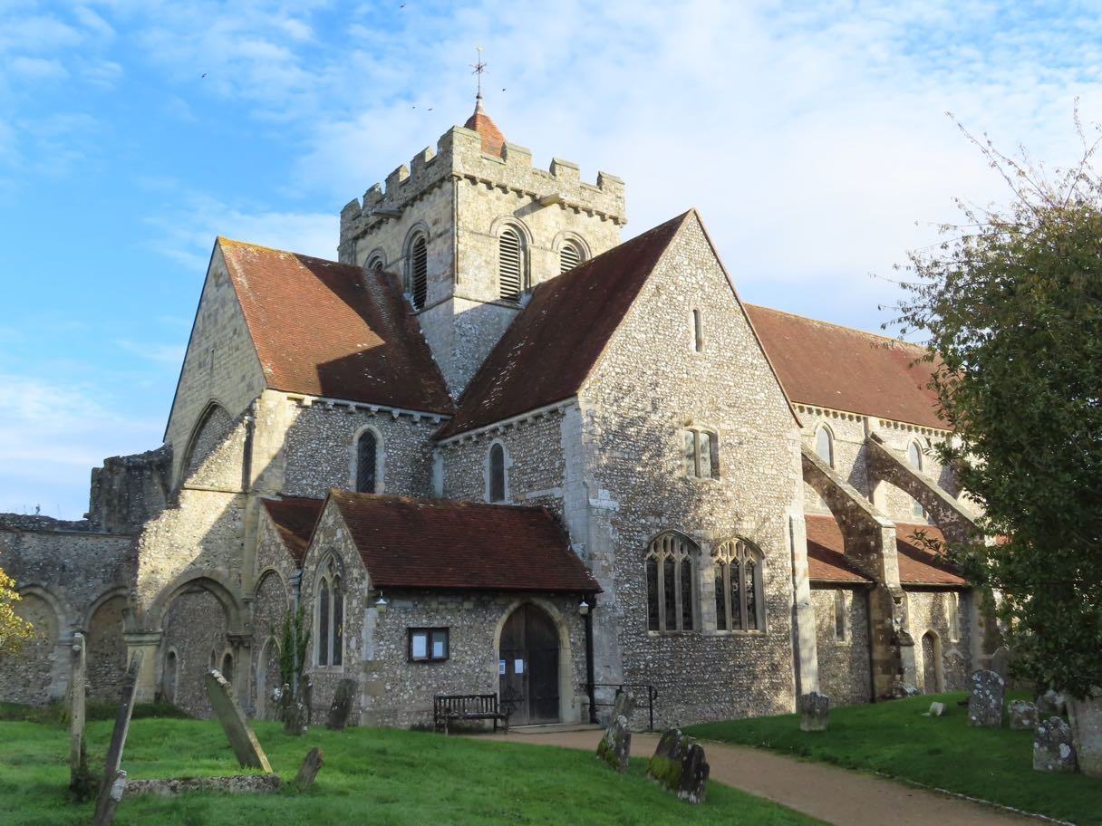

Ruins of the monastic buildings of Boxgrove Priory (Grade 1)
To the north of the church are the remains of the guest-hall of the Priory. C12. Flints and stone rubble. The north and south walls with gable ends are more or less complete. The east and west walls only partly survive.

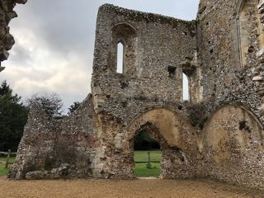

Elm Cottage [near S end of Priory Close]
Dated 1742. Two storeys. Three windows. Faced with coursed flints with brick dressings, quoins, string course and modillion eaves cornice, all now painted. Tiled roof. Casement windows. Doorway with flat hood over. Stone with the date 1742 and the initials 'J.W.'.

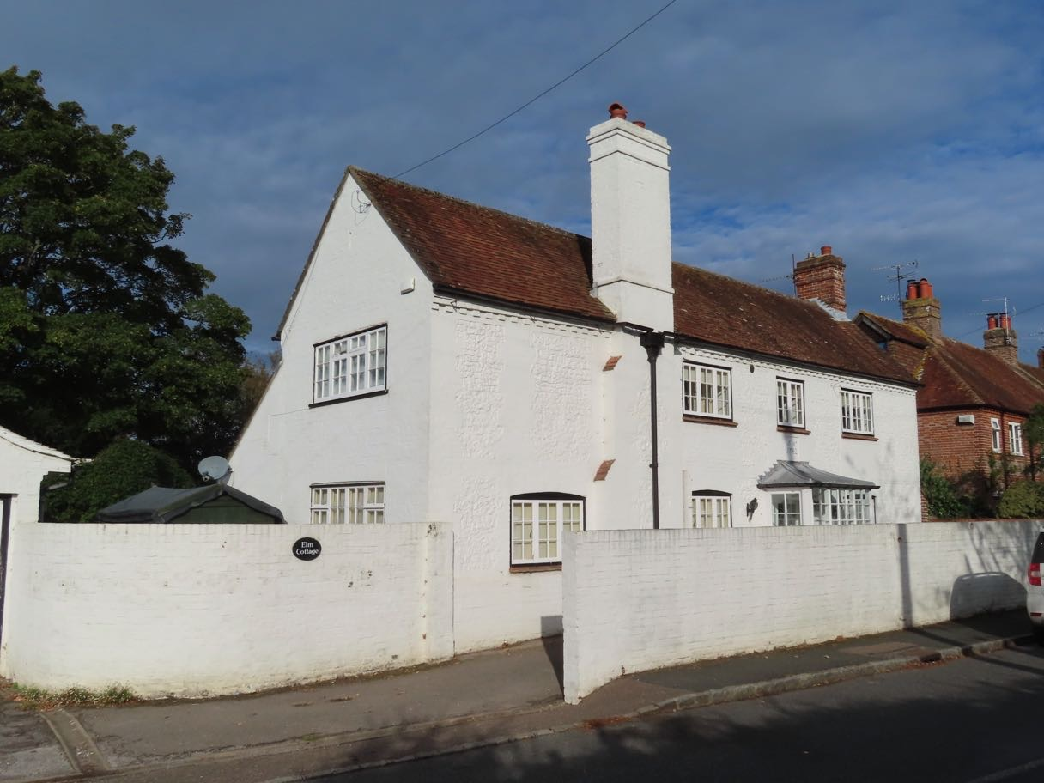

Rosetree Cottage [next to Elm Cottage]
C18. Two storeys. Four windows. Stuccoed. Modillion eaves cornice. Tiled roof. Casement windows on first floor, sash windows with glazing bars on ground floor. Doorway with flat hood over. Westernmost window-bay recessed with ground floor addition of one window-bay beyond. Later additions to north.

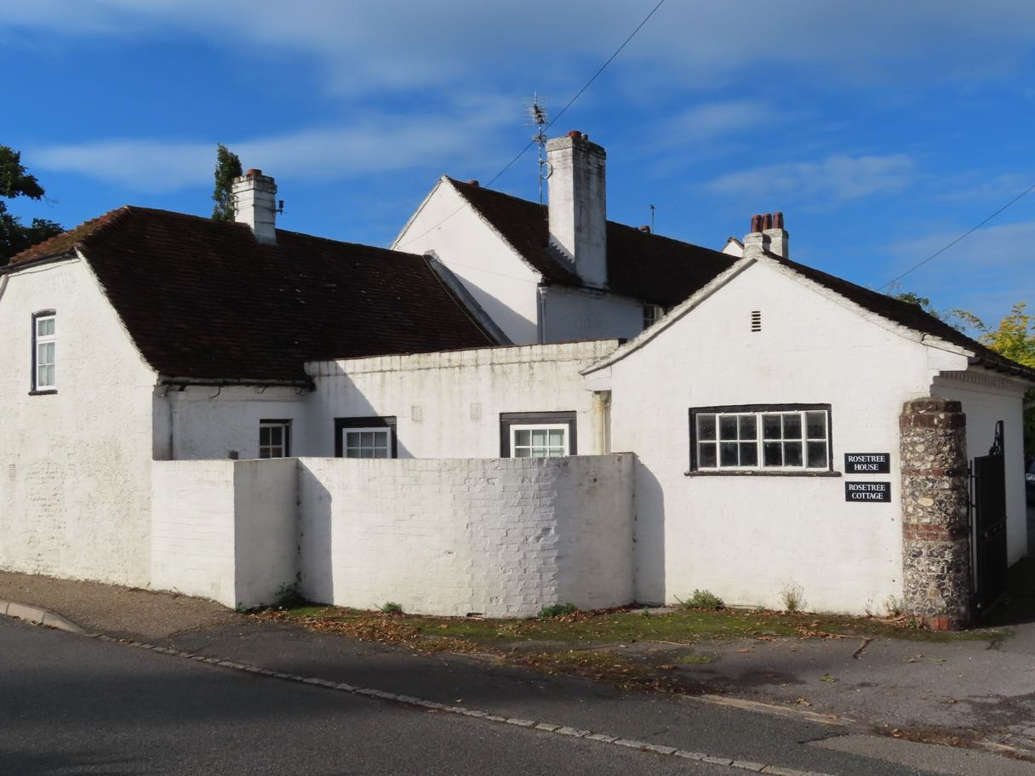

Listed buildings in Halnaker

North from Oakford Park:

Warehead Farmhouse
Early C19. Two storeys. Three windows. Faced with knapped flints with red brick dressings and quoins. Eaves cornice. Hipped tiled roof. Windows with Venetian shutters and glazing bars intact. Square porch.

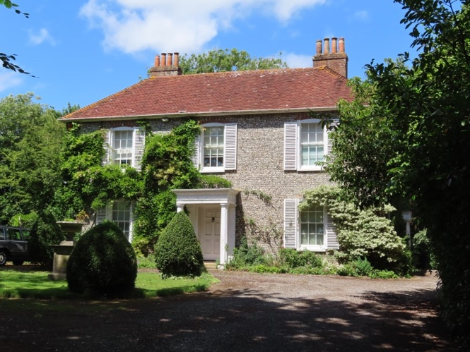

Warehead Cottage
Probably C17. Two storeys. Four windows. Faced with flints with red brick dressings and quoins. Tiled roof with pentice (an extension of a building's roof) to west, probably once thatched. Casement windows.

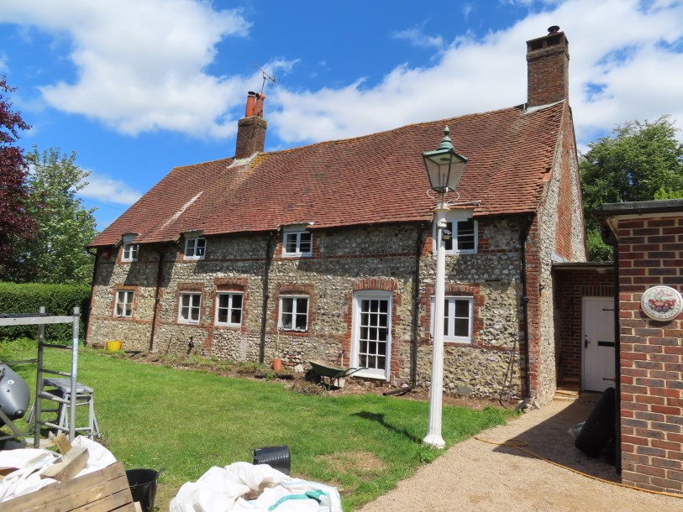

Mill Cottage
C16 timber-framed building with flint infilling and curved braces, ground floor built out in flints with tiled roof. Casement windows. Tiled roof with pentice to west. Two storeys. Three windows.

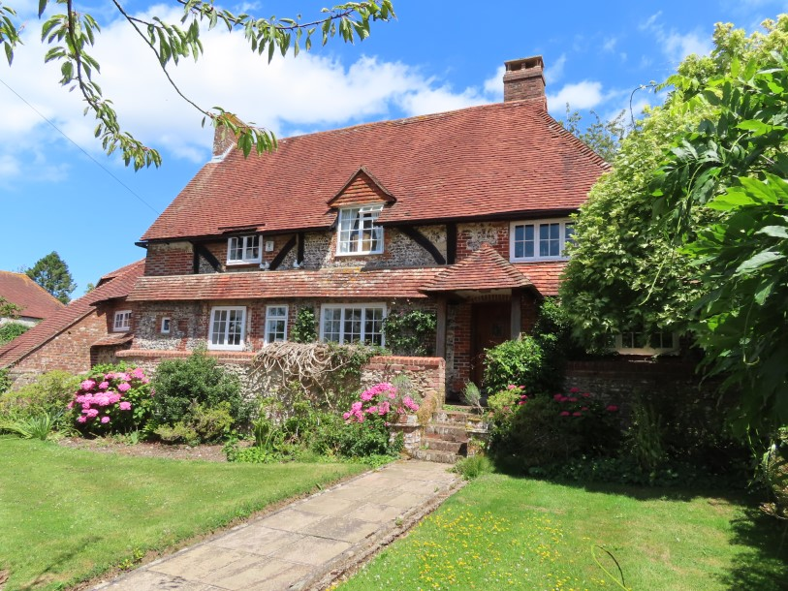

Halnaker Windmill

A mill on Hanaker hill was noted as present in 1301 in the will of Robert de St John. A prominent landmark set 128m high on an outlier of the South Downs, it is a prominent landmark. Built in 1740 it was a tower-mill with hand wheel winding by pulling on an endless chain hanging down at ground level. The last milling family was that of Watkins who lived in the mill house close by from 1868 until 1905 when lightning split the main shaft carrying the sweeps and rendered the mill unusable. No repairs were made and the mill became derelict. In 1934 a major restoration of the outside was carried out by Neves of Heathfield as a memorial to the wife of Sir William Bird, the owner of Eartham House. The damaged wooden wind-shaft was removed and an iron one, specially extended to fit, was put in from Punnett’s Town wind saw mill near Heathfield. New sweeps were also fitted, replaced in 1956 and again in 1994. The empty brick tower had its windows filled in and a new 16-sided beehive cap put on. The working mill was four floors high, Halnaker not needing the usual fifth level as there was so much wind available.*. It is brick built, now covered with burnt Sussex tiles.

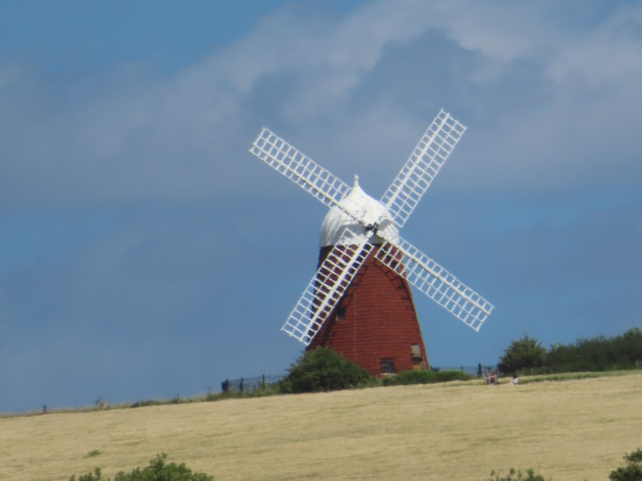

Hilaire Belloc (British-French writer and historian during the early twentieth century who grew up in Slindon) even wrote a poem about the mill:

Sally is gone that was so kindly
Sally is gone from Ha’nacker Hill
And the Briar grows ever since then so blindly
And ever since then the clapper is still
And the sweeps have fallen from Ha’nacker Mill

Ha’nacker Hill is in Desolation
Ruin a-top and a field unploughed
And Spirits that call on a fallen nation
Spirits that loved her calling aloud:
Spirits abroad in a windy cloud.

Spirits that call and no one answers;
Ha’nacker’s down and England’s done,
Wind and Thistle for pipe and dancers
And never a ploughman under the Sun
Never a ploughman. Never a one.*

- From ‘Boxgrove: History of a Sussex Village’ 2000. The Boxgrove History Group.

Historic WW2 structures near the windmill

As countless walkers will have discovered, Halnaker Hill has a commanding view over the coastal plain. In the Second World War therefore, it was a perfect place to install direction finding equipment to detect German aircraft.
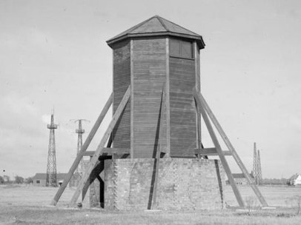
Four octagonal brick structures were constructed on the hilltop, on the S, SE, E and N sides of the hill.

The first three had an octagonal base with a central holdfast, surrounded by a 2.6m high brick wall, with an entrance to the SE corner; these were topped by a wooden structure which contained the radio direction finding equipment.

The wooden structures that topped the three octagonal towers have long since gone, but the lower brickwork and concrete bases survive to varying degrees. One tower, on the SE side of the hill, (SU 9207 0964) and constructed of red bricks, is almost complete:

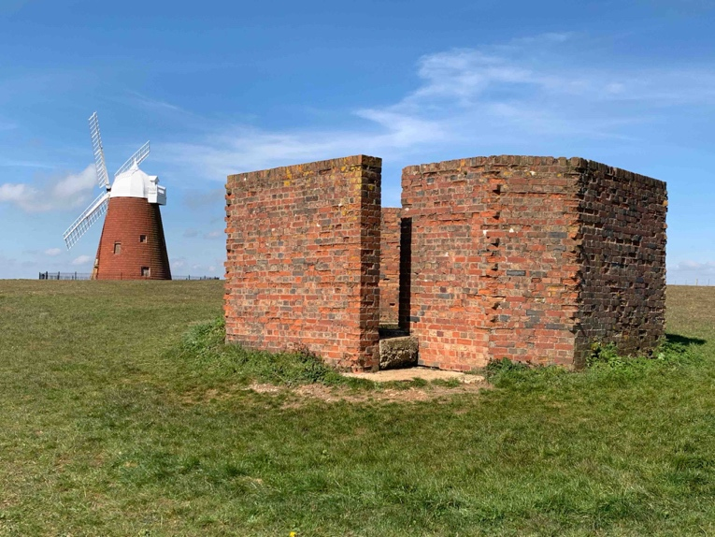
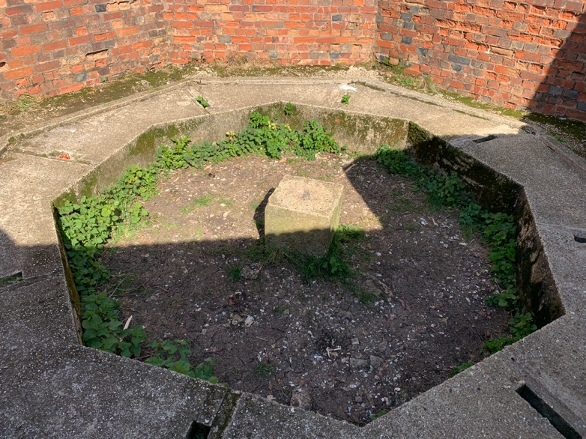

On the E side, a second tower is constructed of soft white bricks (SU 9211 0973) and has been partly demolished.

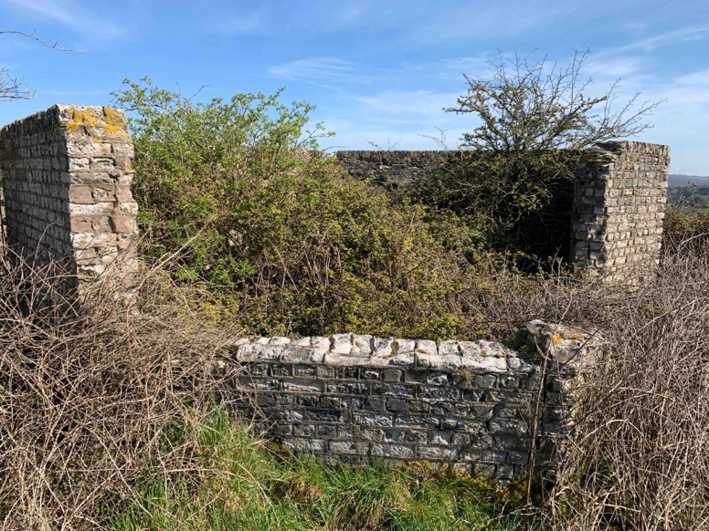

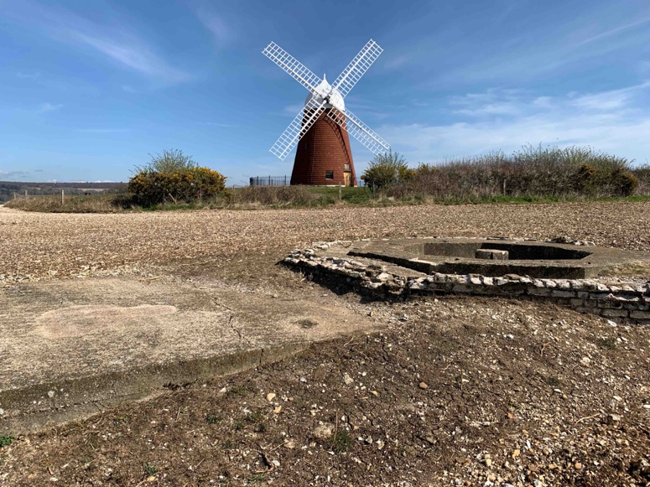

While on the S side [on the left before going past the gate towards the windmill] (SU 9196 0961) the third tower has been demolished down to ground level with only the concrete base and holdfast surviving. This tower was also constructed from white bricks and has an adjacent rectangular base on its W side, presumably for a building.

A fourth octagonal structure is located on the N side of the hill (SU 9205 0982) with its large metal tank alongside. It was topped with a concrete roof, through which was a small entrance into the interior, and alongside was a large steel tank with pipework running into the brick structure.

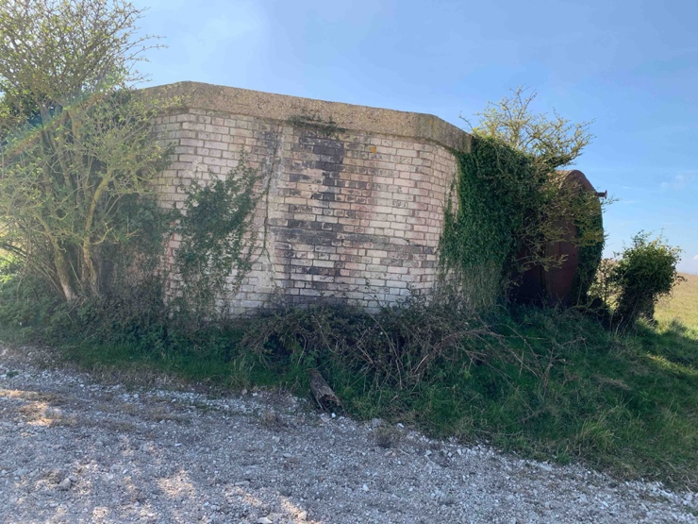
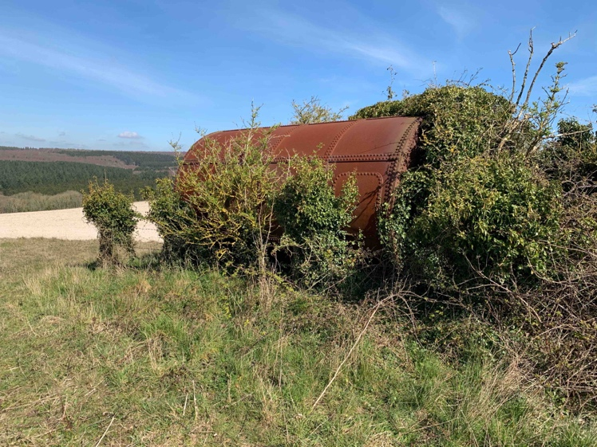

There is a single pipe that runs from the N end of the tank via a pump mechanism and valved before emerging inside the structure. The interior walls are covered with soot and the only access is through a square hole in the roof, and it was probably for creating a smokescreen.*

There were also a number of ancillary buildings, as witnessed by the flat concrete foundations nearby, which were probably the bases for wooden engine rooms for both the smoke screen equipment and for providing power to the direction finders.

The windmill itself was used in wartime as an Observation Post.

* West Sussex under attack: anti-invasion sites 1500-1990. 2008. Chris Butler. (Note that some older publications refer to the site, erroneously, as an anti-aircraft battery).

Opposite Oakford Park:

Halnaker Park
This is one of the later houses of Sir Edwin Lutyens, built in 1938. The main wing faces south and has a hipped projection at each end with a pergola joining them. Two storeys, and attic. Painted brick. Tiled roof. Sash windows with glazing bars. The centre portion has four windows and four hipped dormers. The wings have 2 windows each, those in the west wing rising the whole height of the building, the first floor of the east wing being an open loggia. Pergola along the west end of the west projection. The north front of the main wing has a pentice (extension of a building's roof) with two tall gables containing two storeys above the ground floor. At its east end is a long service wing projecting north at right angles. The east front of this has six windows and 5 hipped dormers and at the north end a pentice with two tiers of two hipped dormer windows. Illustrated in Vol I of the Commemorative volumes on Lutyens

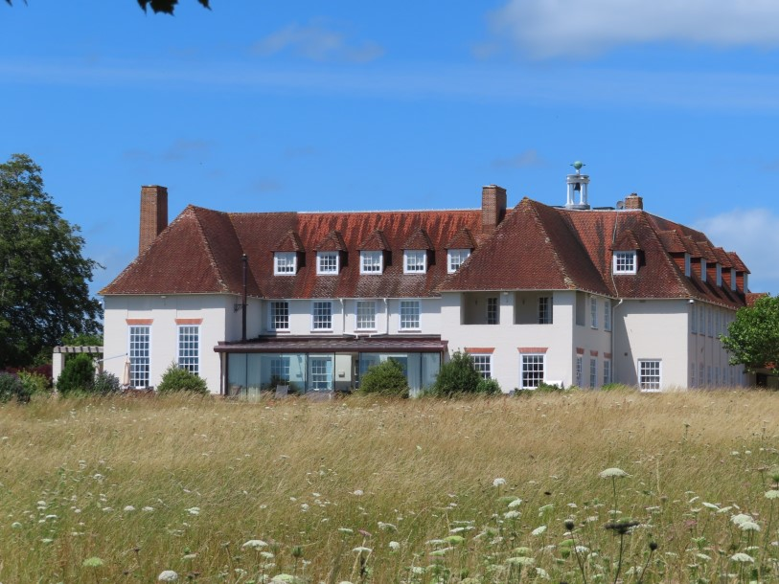

South from Oakford Park:

46-47 [RHS set back]
Pair of cottages. Mid C19 building of the type known locally as Duchess Cottages. Half-H type plan. Two storeys. Four windows. Coursed flints with dressings, quoins, string course and dripstones over the windows of old brick and grey headers. Tiled roof. Casement windows. The outer window-bays project with gables over.

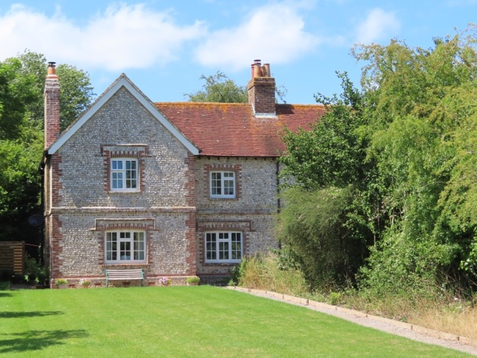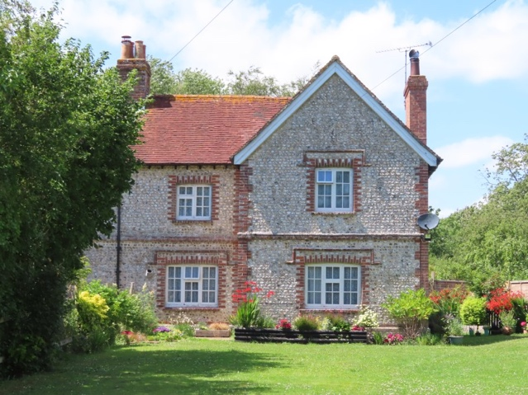

48-49 [first on LHS after Tinwood road]
One building, T-shaped. Mid C19. Two storeys. Four windows. Coursed flints with dressings, quoins and dripstones over the windows of red brick and grey headers. Tiled roof. Casement windows. Two gables to west wing.

Pear Tree House [RHS immediately before Broadlands]
C18. Two storeys. Three windows. Red brick and grey headers alternately. String course. Tiled roof. Casement windows. Doorway with flat hood on brackets.

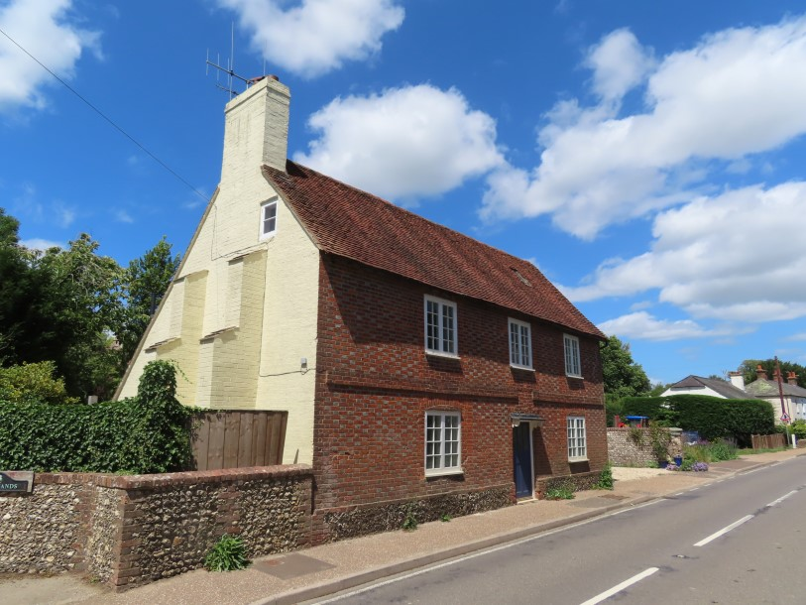

45 Broadlands
C16 timber framed cottage with plaster or red brick infilling, east and south walls refaced with flints with stone quoins. Hipped thatched roof. Casement windows. One storey and attic. One window and one blocked window-space.

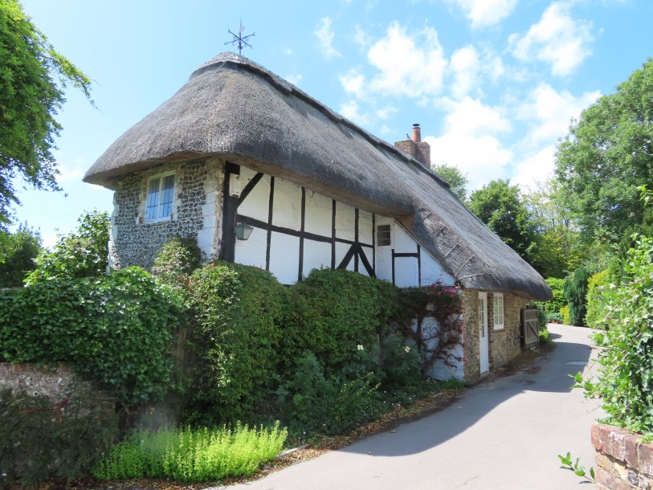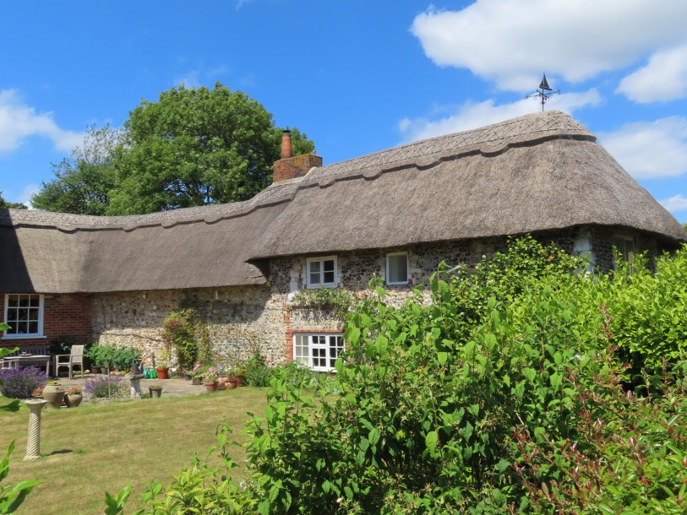

Anglesey Inn [as named in the Historic England list]
Early C19 (?1815). Two storeys. Two windows. Red brick and grey headers alternately. Modillion (ornate corbel) eaves cornice. Tiled roof. Glazing bars intact. Stuccoed doorway with pilasters (regular column) and pediment (consisting of a gable, usually triangular).

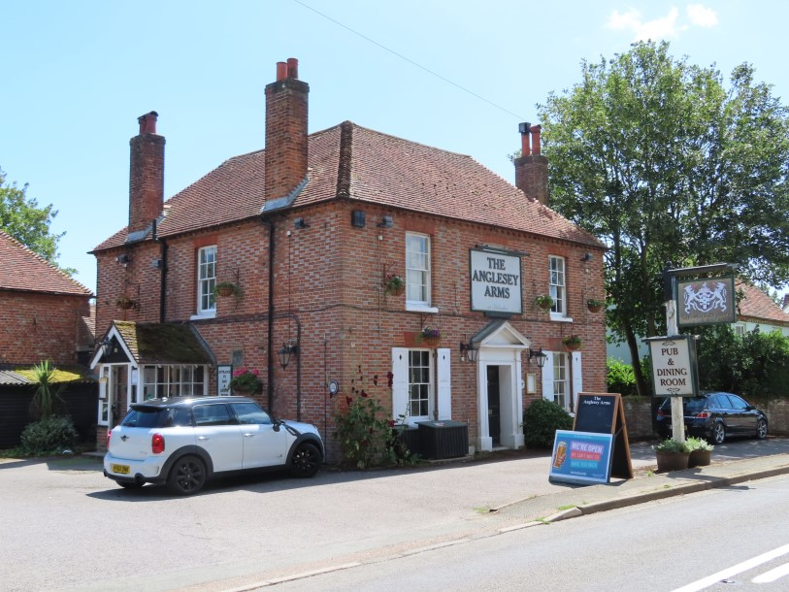

Old Forge Cottage [diagonally opposite pub)
C18. Two storeys. Two windows. Painted brick. Tiled roof. Casement windows.

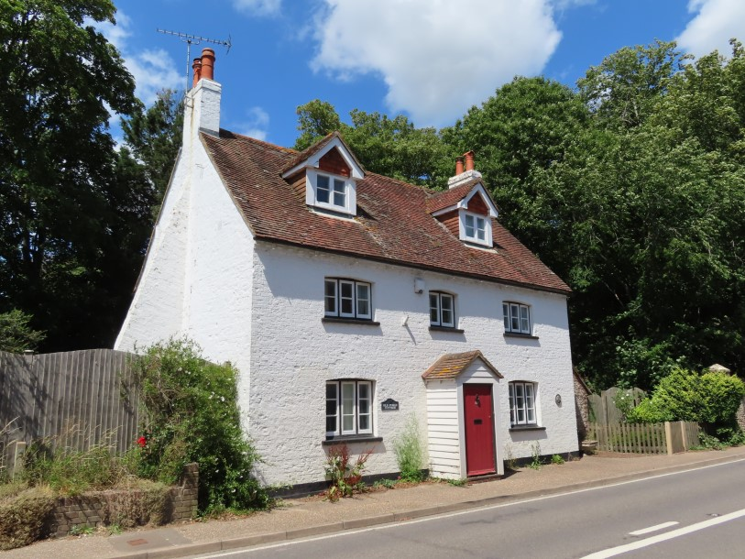

40-41 [flint cottages on LHS after pub]
One building. Mid C19. T-shaped building. Two storeys. Four windows. Coursed flints with dressings, quoins and dripstones over the windows. Red brick and grey headers. Tiled roof. Casement windows. Central gable and smaller flanking gables.

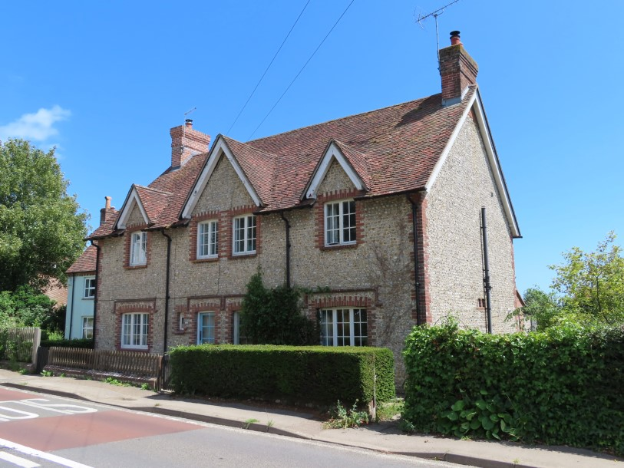

Rose & Jasmine Cottages [last on RHS before Boxgrove junction]
Once three or four cottages. Probably C17. Two storeys. Four windows. Faced with flints with dressings, quoins and vertical strips all of red brick. Tiled roof. Casement windows.

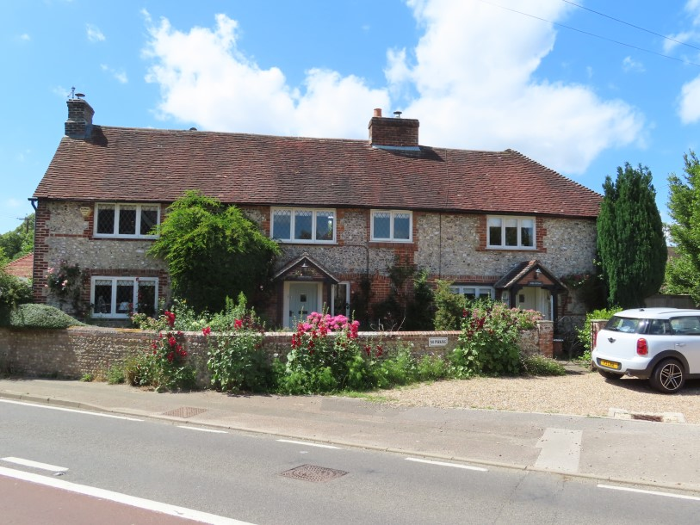

Swan tea room The Old Store [RHS at junction]
One building. Late C18 or early C19. Two storeys and attic. Three windows. Two C19 gabled dormers. South east front red brick and grey headers, north west front faced with flints with red brick dressings and quoins. Modillion brick eaves cornice. Tiled roof. Glazing bars intact. Small shop window at south west end of south east front.

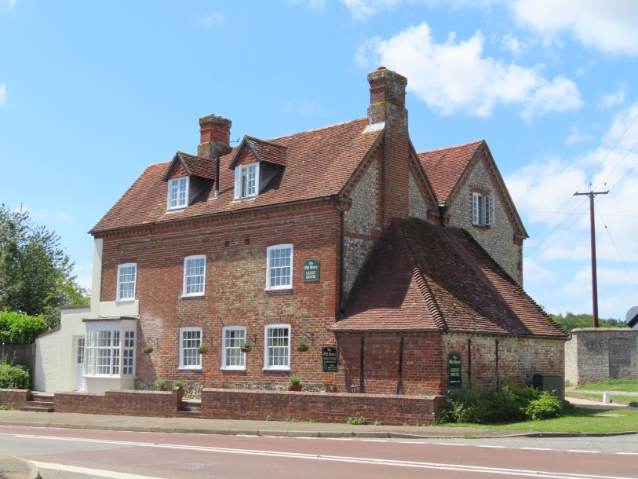

SE Gateway to Goodwood
Early C19. Round-headed carriage archway of flints set in galletting with cove over and tiled coping. Circular holes in the spandrels (the space between the shoulders of adjoining arches and the ceiling or moulding above). The Gates described do not give entrance to Goodwood Park but to a part of the Estate which is in agricultural use, including the Home Farm. The road to which they lead has no name.

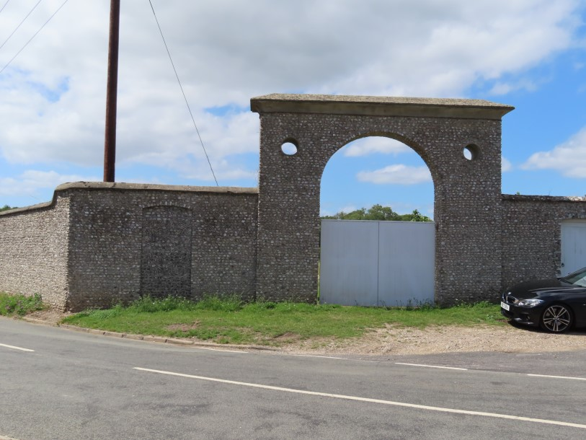

Halnaker House
1777. L-shaped building. Two storeys. Six windows. East wing faced with flints with red brick dressings, quoins and string course. South wing red brick and of taller elevation. Tiled roof and glazing bars intact to the whole. For Lady Sarah Lennox, daughter of the Duke of Richmond, afterwards Lady Sarah Napier, with whom George III fell in love in youth.

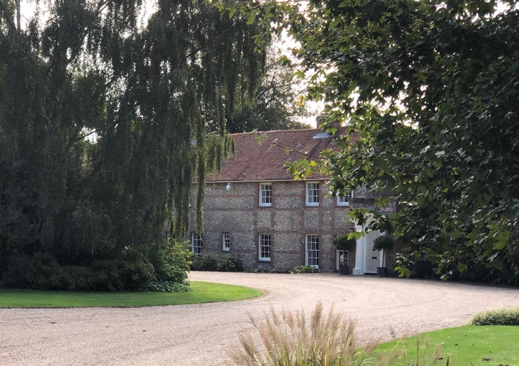

Halnaker Park Cottage
Formerly two cottages, now one house. C17 building, refaced with red brick. String course. Tiled roof. Casement windows. Two storeys. Six windows.

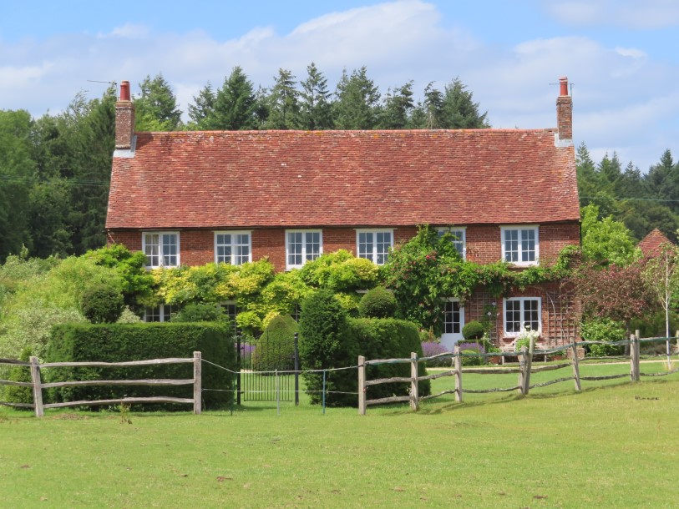

OLD HALNAKER HOUSE (Grade 1)
The de Haye family built a big mansion here in the C13, which was altered in the C16 and fell into ruins about 1800. What remains are the Lavant stone gateway in the centre of the south front with square towers, and parts of the C13 chapel and C14 hall in flints.

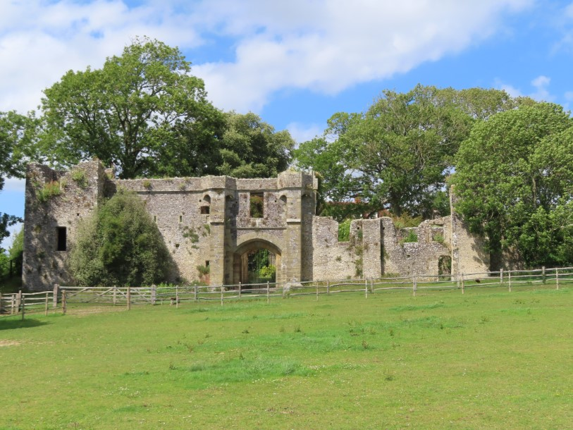

This list has been sourced from The National Heritage List for England (www.historicengland.org.uk) and compiled with photos added by Dr John Bennett and Beryl Bakewell, Halnaker
January 2021

